**DAILY ONLINE ACTIVITIES SUMMARY**

|  |  |  |  |  |  |  |  |  |
| --- | --- | --- | --- | --- | --- | --- | --- | --- |
| **Date:** | **28/05/2020** | | | | | **Name:** | **Lavanya D M** | |
| **Sem & Sec** | **4th & ‘A’** | | | | | **USN:** | **4AL18CS041** | |
| **Online Test Summary** | | | | | | | | |
| **Subject** | | **MES and Kannada** | | | | | | |
| **Max. Marks** | | **MES=20**  **KANNADA=50** | | **Score** | | | **MES=16**  **KANNADA=36** | |
| **Certification Course Summary** | | | | | | | | |
| **Course** | **Learn Web Design: The Ultimate Guide For Beginners** | | | | | | | |
| **Certificate Provider** | | | **Bitdegree** | | **Duration** | | | **3days,3hrs** |
| **Coding Challenges** | | | | | | | | |
| **Problem Statement:** 1) In an array X of size M where the array elements contain values from 1 to M with duplicates, the task is to find total number of sub arrays which start and end with the same element  2) C program to find digital root of a number | | | | | | | | |
| **Status: complied** | | | | | | | | |
| **Uploaded the report in GitHub** | | | | | **Yes** | | | |
| **If yes Repository name** | | | | | <https://github.com/lavanyamurthi/lockdown-coding> | | | |
| **Uploaded the report in slack** | | | | | **Yes** | | | |

Online Test Details: (Attach the snapshot and briefly write the report for the same)

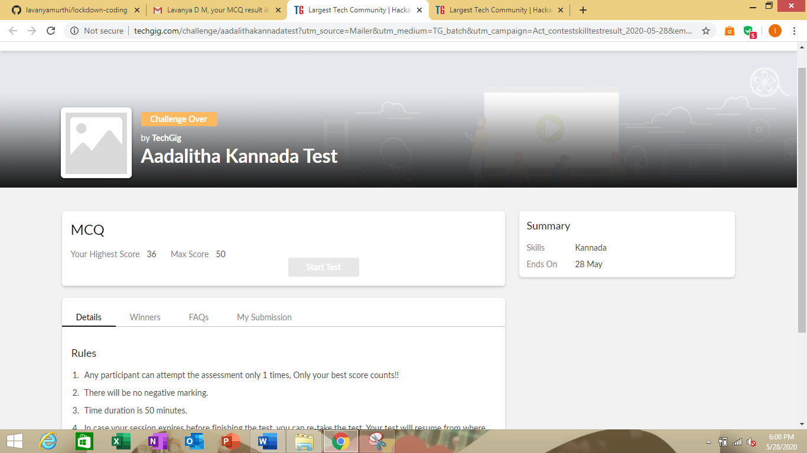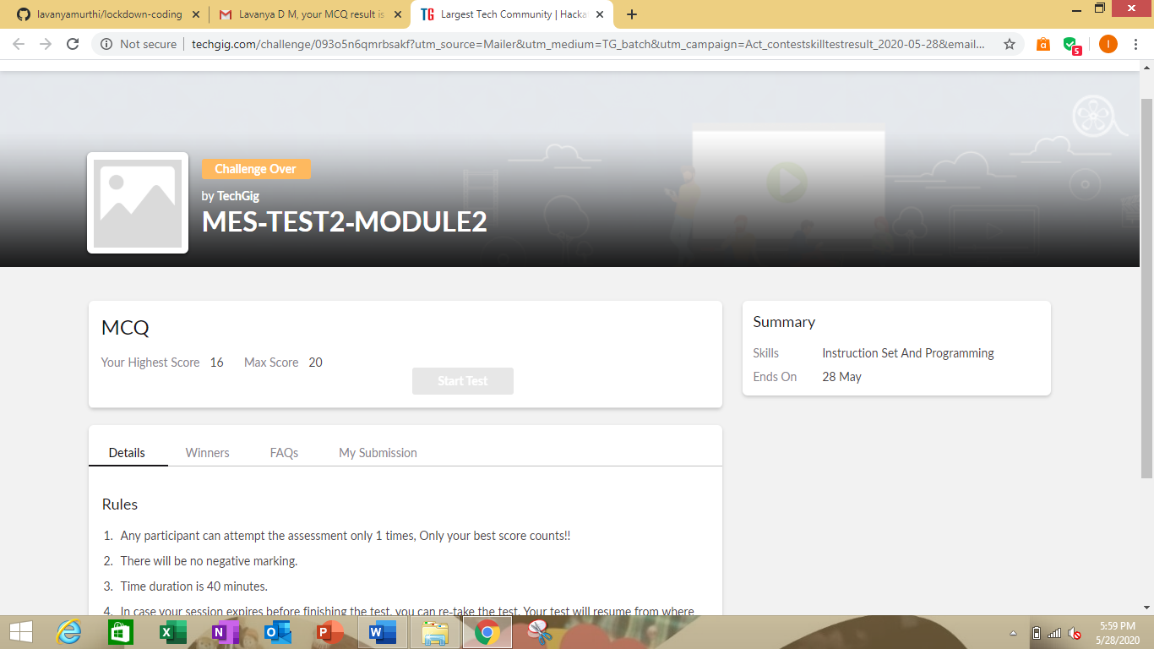

Certification Course Details: (Attach the snapshot and briefly write the report for the same)

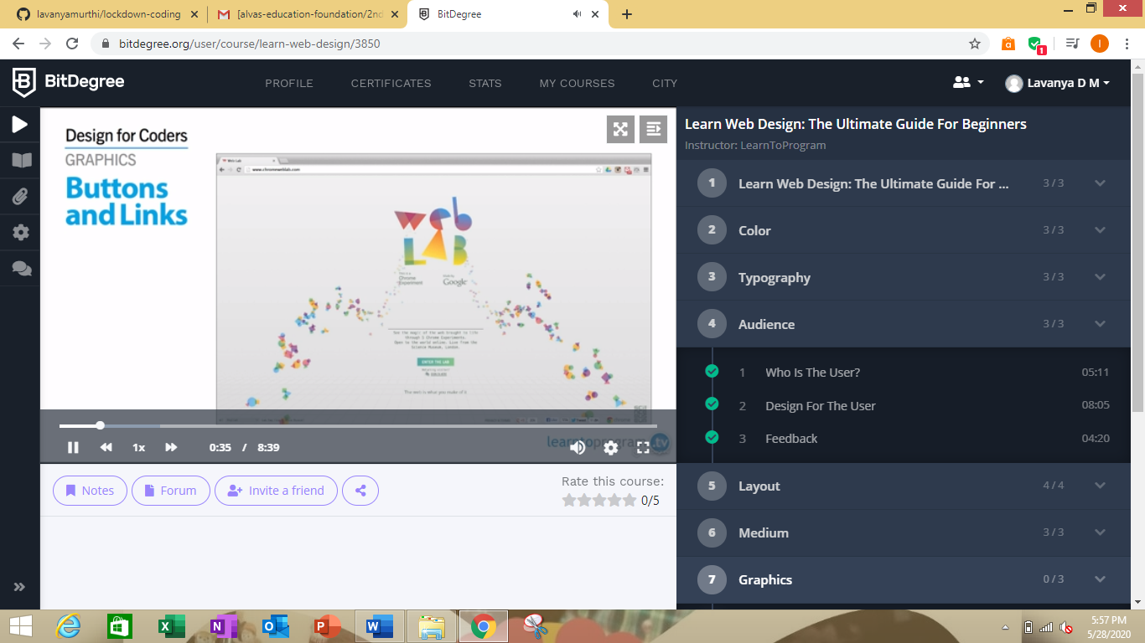

Here I’m learning how to add colors, design for web page

This is the GitHub repository link <https://github.com/lavanyamurthi/lockdown-certificate/blob/master/Certi28may.PNG>

Coding Challenges Details: (Attach the snapshot and briefly write the report for the same)

Problem1:n an array X of size M where the array elements contain values from 1 to M with duplicates, the task is to find total number of sub arrays which start and end with the same element. (#85)

|  |  |  |  |
| --- | --- | --- | --- |
| Example: Input: X[] = {1, 2, 1, 5, 2} Output: 7 Explanation: Total 7 sub-array of the given array are {1}, {2}, {1}, {5}, {2}, {1, 2, 1} and {2, 1, 5, 2} are start and end with same element. |  |  |  |
|  | | |

Problem2: C program to find digital root of a number.

Description:  
A digital root is the recursive sum of all the digits in a number. Given n, take the sum of the digits of n. If that value has more than one digit, continue reducing in this way until a single-digit number is produced. This is only applicable to the natural numbers.  
digit_root(0)= 0

digital_root(16)  
=> 1 + 6  
=> 7

digital_root(132189)  
=> 1 + 3 + 2 + 1 + 8 + 9  
=> 24 ...  
=> 2 + 4  
=> 6

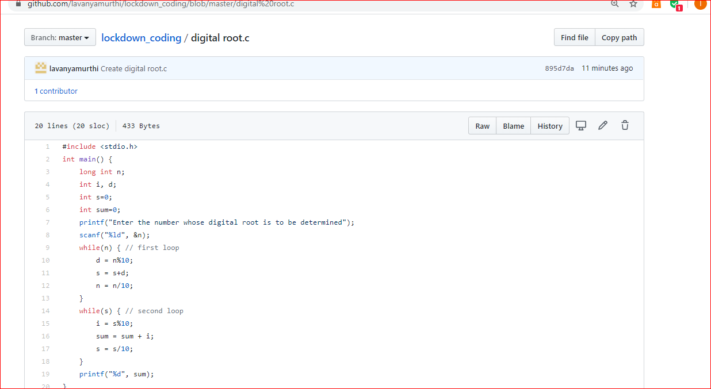

Here I provided the GitHub repository link of coded program

<https://github.com/lavanyamurthi/lockdown-coding/blob/master/digital%20root.c>

<https://github.com/lavanyamurthi/lockdown-coding/blob/master/sub%20array.c>